The Society for Textual Scholarship’s

2022 Conference Program DRAFT

Cultural Mappings

Loyola University Chicago, May 26–28

Land Acknowledgment
The Loyola University Chicago community acknowledges its location on the ancestral homelands of the Council of the Three Fires (the Ojibwa, Ottawa, and Potawatomi tribes) and a place of trade with other tribes, including the Ho-Chunk, Miami, Menominee, Sauk, and Meskwaki. We recognize that descendants of these and other North American tribes continue to live and work on this land with us. We recognize the tragic legacy of colonization, genocide, and oppression that still impacts Native American lives today. As a Jesuit university, we affirm our commitment to issues of social responsibility and justice. We further recognize our responsibility to understand, teach, and respect the past and present realities of local Native Americans and their continued connection to this land.

Conference Protocol
All participants and events are required to create an environment in which people share their ideas rigorously and free of harassment. Any language, gestures, and behavior that creates a hostile or intimidating setting based on identity markers will not be tolerated and the person responsible will not be allowed to remain in the STS conference.

§§§

THURSDAY, MAY 26
The Corboy Law Center, Loyola

8:30–9:15 am

Welcome
Preview of the Conference
Coffee & light refreshments

9:30–11:30 a.m.

Plenary Session: Mapping the Intersections of Text, Space, & Pilgrimage Sites
Moderators: Edmondo Lupieri (Loyola University Chicago) & Olivia Stewart Lester (Loyola University Chicago)
- Laura Carnevale (University of Bari), “Re-mapping Sacred Spaces”
- Fabio Caruso (University of Foggia), “Re-mapping Sacred Traditions”
- Edmondo Lupieri (Loyola University Chicago), “Re-mapping Sacred Images”
- Josefrayn Sánchez-Perry (Loyola University Chicago), “Re-mapping Sacred Time: Calculating Ritual Fests in Christian Mesoamerican Calendars”

Lunch
(STS Executive Board Meeting: Working Lunch, 11:30–1:00 p.m.)

1:00–2:30 p.m.

Afternoon Coffee / Tea / Water Refills

1a: Mapping Works & Versions
Moderator: TBD
- Paul R. Eggert (Loyola University Chicago), “Writers mapping their pasts vs the scholar’s mapping: Two concepts of the oeuvre, and the editorial consequences”
- Russell McDonald (Georgian Court University), “Editorial Slut-Shaming: Textual Variants Between the American and British First Editions of Rebecca West’s ‘The Return of the Soldier’”
- John K. Young (Marshall University), “Tokens, Types, Works, Texts: Contemporary Black Literature and the Cartography of the Printed Page”

1b: Critical Editions for Digital Analysis and Research (CEDAR)
Moderator: TBD
- Ellen MacKay and Sarah Gray Lesley (University of Chicago), “Beshrew Me!, a collation of the two very different dispositions of The Taming of A/The Shrew that aims to identify and source the citation of domestic culture—and specifically the wide array of shrew-making and shrew-taming matter that comprise it”
- Miller C. Prosser (University of Chicago), “Overview of CEDAR as an OCHRE project, from the underlying database ontology through the data lifecycle to publication, detailing how OCHRE is designed as a database solution for research in the humanities and social sciences”
- Sarah Yardney (University of Chicago), “The Bible sub-project, demonstrating how CEDAR is used to map text-critical differences in ancient biblical manuscripts, both within and across language traditions”

2:45–4:15 p.m.

2a: Futures in Digital Editing I: Problems in Data Capture, Text, and Publication Moderator: John Bryant (Hofstra University, Emeritus)
- John Bryant (Hofstra University, Emeritus), “Mapping is Editing & Editing as Mapping: MEL’s Itinerary, A Critical Mapping Tool”
- Christopher Ohge (University of London), “Static versus Dynamic? The Challenges of Publishing a Fluid Text Edition, and the Promises of Minimal Computing Solutions”
- Miller C. Prosser (University of Chicago), “From Intertwingularity to TEI and Beyond: Data Integration and Publication in OCHRE (Online Cultural and Historical Research Environment)”

2b: Cartographies of Origins and Heritage
Moderator: Matt Cohen (University of Nebraska)
- Chadwick Allen (University of Washington), “Replicas and Reactivations: Mapping Indigenous Earthworks Futures”
- Gabrielle Dean (Johns Hopkins University), “Within, Beneath, and Beyond the Landscape: Learning to Read a Historically Black Cemetery”
- Scott Harris (Loyola University Chicago), “The Cartography of Origins: The Fragments of Artapanus and Colonial Foundations in Hellenistic Egypt”
- Xin Yu (Washington University, St. Louis), “Mapping Ancestry in Early Modern China”

4:30–6:00 p.m.

Afternoon Coffee / Tea / Water Refills

3a: Futures in Digital Editing II: Interacting with Data; Rethinking Editions
Moderator: Christopher Ohge (University of London)
- Ian Cornelius (Loyola University of Chicago) & Timothy Stinson (North Carolina State University), “PPEA 3.0: The Piers Plowman Electronic Archive and CEDAR”
- Elizabeth Dillon (Northeastern University), “Decolonization and the Digital Archive: The Early Caribbean Digital Archive and Embedded Slave Narratives”
- Ed Garcia (University of Chicago), “Digitizing Mesoamerican Pictography”
- Nicole Gray (University of Nebraska), The Walt Whitman Archive and Data Transformation as Editing
- Christopher Ohge (University of London), “Editorial Intentions and Network Analysis in the Anti-Slavery Anthology The Bow in the Cloud”

3b. Critiques of cartographic representation
Moderator: TBD
- Nikki Fragala Barnes (University of Central Florida) & Mark Dixon (Independent Scholar), “An Unmappable Present: Texts and Theories that Fail and Collaborative Wayfinding”
- Brian Cook (Auburn University), “Mapping Beowulf: The Damage It Causes and Why We Should Stop Trying”
- Clayton McCarl (University of North Florida), “Cartographic Hauntings: Mapping Documents of the Lost African American Past of Jacksonville, Florida” (Virtual / Live)
- Chiara Palladino (Furman University), “Beyond Mapping: Challenges in Representing Non-Cartesian Geographies in Cartesian Times”

6:15–7:30 PM

Opening reception, The Corboy Law Center
Presidential Address

§§§

FRIDAY, May 27
The Newberry Library (morning)
&
The Corboy Law Center, Loyola (afternoon)

Rettinger Hall, The Newberry Library

8:15–9:00 a.m.

Welcome to The Newberry
Coffee & Tea

9:00–10:30 a.m.

The Greetham Lecture: Izhi-aazhogeng: On Redescribing Cultural Artifacts and Identities
Moderator: Matt Cohen (University of Nebraska)
- Rose Miron (Director of the D’Arcy McNickle Center for American Indian and Indigenous Studies, The Newberry Library)
- Margaret Noodin (University of Wisconsin, Madison)
- Blaire Topash-Caldwell (University of Massachusetts, Boston)
- Kelly Wisecup (Northwestern University)

10:45–12:00 p.m.

An Exhibition featuring materials from the Newberry Library’s D'Arcy McNickle Center for American Indian and Indigenous Studies and from its extensive cartographic collections will be available for viewing throughout the morning.
Host: Will Hansen, Director of Reader Services and Curator of Americana

4a: Mapping authors and texts in European journals after World War II
Moderator: TBD
- Leonardo Canova (University of Pisa)
- Elena Grazioli (University of Pisa)
- Antonietta Sanna (University of Pisa) (Virtual / Live)

4b: Troubling Dickinson’s Textual Identities in Manuscript and Print
Moderator: Marta Werner (Loyola University Chicago)
- Samantha L Anders (Loyola University Chicago), “‘I would not exchange the Bolt For all the rest of Life’: Grief in Emily Dickinson’s Late, Intergeneric Works”
- Theo Gray (Loyola University Chicago), “Dickinson’s ‘Manuprints’: Mapping the Middle Space Between Script and Print”
- Emma Horst (Loyola University Chicago), “Emily Dickinson’s Poem Manuscripts: The Troubling of Poetic Identity and Reader Experience in Two Versions of ‘Two Butterflies’”
- Nicole Salama (Loyola University Chicago), “Boxing in Dickinson: The Bibliographic Codes of Price in the Roberts Brothers’ Editions of Emily Dickinson’s Poetry”

12:00–1:30 p.m.

Lunch in Chicago-at-Large
Note: Afternoon sessions will take place at The Corboy Law Center, Loyola

The Corboy Law Center

Afternoon Coffee / Tea / Water

1:30-6:00 p.m.
Flash Presentations will available for viewing throughout the afternoon in Kasbeer Hall.
(This section is under development.)
- Matteo Maselli (Università di Macerata), “Database Allegorico Dantesco (DAD). Functions and structure of a new digital resource” (Flash Talk)
- Victoria Sciancalepore (Jane Addams Papers Project), “Mapping Women’s Peace and Suffrage Communities Through the Jane Addams Papers” (Flash Exhibit)
- Marta Werner (Loyola University Chicago), “Dickinson’s Data Choruses” (Flash Sound Installation)

1:30–3:00 p.m.

5a: Archives, Databases, Tools
Moderator: TBD
- Barbara J. Bair (Library of Congress), “Geopoetics & the Accessible Text: Harjo & Arendt Digital Resources from the Library of Congress”
- Robert McQueen (Boston College), “The Hannah Arendt Index: Full Text Search on LOC Archive”
- Sarah L Noonan (St. Mary’s College) & Elizabeth Hebbard (Indiana University Bloomington) “Mapping Medieval Manuscripts in the Midwest”
- Ricardo Vazquez-Diaz (University of Pittsburg), “Visualizing transduction with Versioning Machine 5.0 in the multimedia genetic dossier of “Diario Indio” by Severo Sarduy”

5b: Textual Scholarship and the Remapping of Ancient Jewish and Christian Texts
Moderator: Olivia Stewart Lester
- Laura Carlson Hasler (Indiana University Bloomington), “Writing Resilience in Jewish Antiquity”
- Mark Lester (Loyola University Chicago), “Remapping Space with Text in Deuteronomy”
- Olivia Stewart Lester (Loyola University Chicago), “Remapping Judaism and Christianity through the Sibylline Oracles”
- James Nati (Santa Clara University), , "What Were Biblical Books? Mapping the Ontology of Literature in Early Judaism"

3:15–4:30 p.m.

6a: Mapping mixed-media artworks
Moderator: TBD
- Maya Patel Day (University of Michigan), “Spatio-Material Intimacy and the Political Thresholds of Access in Layli Long Soldier’s Quilts”
- Ileana Marin (University of Washington, Seattle), “Mapping the Reading of Artists’ Books” (Virtual / Live)
- Diana C. Proezna (University of Maryland, College Park), “Delay in Print: Mapping the Textual Legacies of Marcel Duchamp's ‘Green Box’”

6b: Semantic mapping, annotation, and literary archives
Moderator: TBD
- Stephanie Browner (The New School), “A Kaleidoscopic Map: The case for annotations for Charles W. Chesnutt’s short stories”
- Esteban Crespo (Yale University), “Mapping Emotions in Early Modern Queer Iberian Archives”
- Michelangelo Zaccarello (Northwestern University), “First Steps Toward a Semantic Mapping of the Italian Literary Heritage (SMILH)”

4:45–6:00 p.m.

Afternoon Coffee / Tea / Water Refills

7a: Geographies of transmission
Moderator: TBD
- Gabriel Ford (Drake University), “Mapping the Manuscripts of Petrus Alfonsi’s Disciplina Clericalis”
- James B. Kuykendall (University of Mary Washington), “The map as an anchor in anthologies of American folksong”
- Ricardo Vazquez-Diaz (University of Pittsburgh), “Cuban Broadcastings (1923–1959): Mapping Radio and Urban Space Relations”
- Jennifer Keith (University of North Carolina at Greensboro), “Winter Fruit: Mapping Early Women Writers’ Networks in Manuscript Archives” (Virtual / Live)

7b: Material practices of composition
Moderator: TBD
- Daniel Balderston (University of Pittsburgh) & Maria Celeste Martin (Emily Carr University), “On ‘The Cult of Books’: Learning from the Manuscript of a Famous Borges Essay”
- Pilar Martínez-Benedi (University of L’Aquila), “‘Sapore di mare’: Pavese’s Fluid Translation of Moby-Dick”
- Kenneth M. Price (University of Nebraska), “Whitman’s Trunk: Rethinking How Whitman Composed”

§§§

SATURDAY, MAY 28
The Corboy Law Center, Loyola

8:15–9:00 a.m.

Welcome to the Final Day of the Conference
Coffee & light refreshments

9:00–10:30 a.m.

8a: Seminar: Subjectivity, Scribal Practice, and the Role of the Textual Scholar
Leaders: Laura Carlson Hasler (Indiana University Bloomington), Mark Lester (Loyola University Chicago), Olivia Stewart Lester (Loyola University Chicago), and James Nati (Santa Clara University)

8b: Mapping the Authorial-Function (Virtual / Live session)
Moderator: TBD
- Paola Italia (University of Bologna), “Digital Manuscript: Authorial philology and computational methodologies”
- Sergio Parussa (Wellesley College), “Mapping Bassani’s Manuscripts”
- Giulia Raboni (University of Parma), “Manzonionline.org: manuscripts, rare books, and bibliographical collecting”

10:45–12:15 p.m.

Plenary: Steven E. Jones (University of South Florida), Busa and the Mapping of Humanities Computing
Moderators: George Thiruvathukal (Loyola University Chicago) and Marta Werner (Loyola University Chicago)

12:30–3:00 p.m.

Closing / Final Conversations / Grab-and-go Lunch

This conference is co-sponsored by the Society for Textual Scholarship, Loyola University Chicago, the Consulate General of Italy in Chicago, the Italian Cultural Institute in Chicago, and Italcultura.

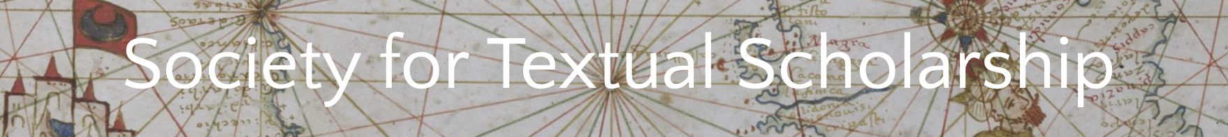

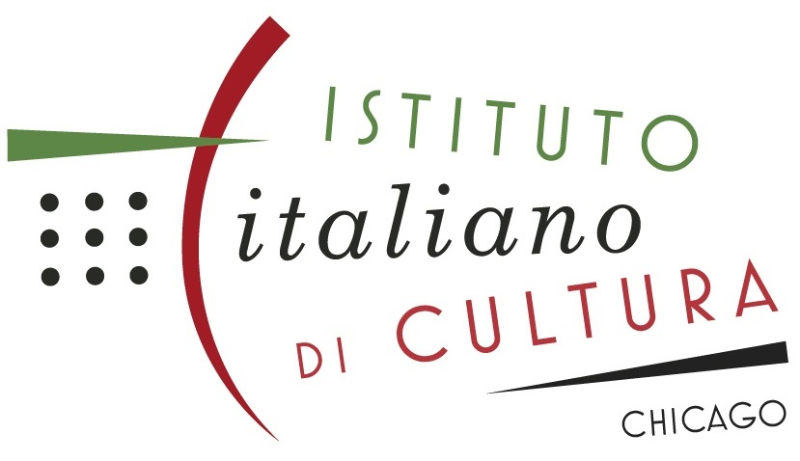

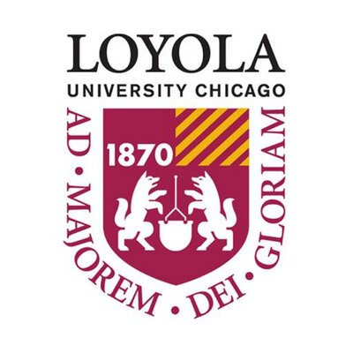

Financial support for STS 2022 is also provided by the Svaglic Chair in Textual Studies, the Surtz Chair, the Cody Chair, and the Departments of English, Theology, and Computer Science.

Finally, we gratefully acknowledge the generous support for this meeting provided by the Conference Organizing Committee, the STS Membership, and an anonymous donor in our midst.

§§§

